Action plan
2019-20



KRISHI VIGYAN KENDRA, GRAM NIRMAN MANDAL, SARVODAYA ASHRAM,
SOKHODEORA, DISTT. NAWADA, BIHAR

Krishi Vigyan Kendra ,Nawada Established by Indian Council of Agriculture Research ,New Delhi in 1979 under Agriculture Technology Application Research Institute Zone II under Gram Nirman Mandal Sarvodaya Ashram Sokhodeora Nawada ,Bihar
About Nawada District
Nawada district lies between 24º30’ and 25º05’ N latitude and 85º17 ‘ and 86º00’ longitude .There are 14 blocks under the district. The northern and southern parts of the district has two distinct physiographic regions. Though average rainfall of Nawada is 1037mm, It is characterized by erratic distribution of rainfall, frequent drought and low production rainfed farming system. Population density is low in comparison to other districts of Bihar .The total population is 18.09 lacs out of which SC and ST comprises 4.38 lacs. The average literacy is 37.13% and the male: female ratio is 1000:946. Southern part of the district faces numerous biophysical and socio- economic constraints such as small and fragmented land holding, huge on farm water losses, soil erosion and land degradation , inequitable agrarian structure and poor infrastructure services and finances.
The absence of any perennial river in Nawada has deprived the district of any important canal system which could provide water for agriculture operation round the year. There are large runoffs and soil losses due to hilly terrain. The difficulties have been partly over come to some extent by the ingenuity and diligence of the people who devised the system of ahars and pynes to harvest rainwater and use it for supplementary irrigation.
KVK System: Mandate and Activities
The mandate of KVK is Technology Assessment and Demonstration for its Application and Capacity Development.
To implement the mandate effectively, the following activities are envisaged for each KVK
1. On-farm testing to assess the location specificity of agricultural technologies under various farming systems.
2. Frontline demonstrations to establish production potential of technologies on the farmers’ fields.
3. Capacity development of farmers and extension personnel to update their knowledge and skills on modern agricultural technologies.
4. To work as Knowledge and Resource Centre of agricultural technologies for supporting initiatives of public, private and voluntary sector in improving the agricultural economy of the district.
5. Provide farm advisories using ICT and other media means on varied subjects of interest to farmers
In addition, KVKs produce quality technological products (seed, planting material, bio-agents, livestock) and make it available to farmers, organize frontline extension activities, identify and document selected farm innovations and converge with ongoing schemes and programs within the mandate of KVK.

Location
The Nawada District is bound in the north by Nalanda and Sheikpura ,south by Giridih and Kodarma east by Jamui and west by Gaya . Krishi Vigyan Kendra is located at Sarvodaya Ashram shokhodeora Nawada 50 km away from district head quarter and 160 km away from state capital Patna .
District Profile

Physical and administrative features | Land utilization in (Ha)
- Total geographical area 2488.42 Sq. Km.  - No of sub Division – 2.  - No of Block – 14.  - No of Villages – 1099.  - No of Panchayats – 189. | - Total area – 248842.0.  - Cultivable land – 149474.0  - Waste land - 10370.5.  - Forest land – 54551.0.  - Non Agri. Land - 34447.0.  - Net Sown area - 110565.0.
Cropping Pattern | Demography
- Paddy – Fallow-Fallow  - Paddy – Wheat – Fallow  - Paddy – Wheat – Green Gram  - Maize – Vegetable – Vegetable  - Maize – Gram – Green Gram  - Maize – Kulthi – Fallow  - Maize – Toria – Fallow  - Maize – Potato – Vegetable  - Paddy – Vegetable – Vegetable  - Fallow – Lentil/Gram – Fallow  - Redgram– Redgram –Redgram | - Total population – 1809696  - Population density - 726  - Male – 929960, Female – 879736  - SC – 435975 (M – 223929, F – 212046)  - ST – 2158 (M-1123, F-1035)  - Others – 1371563 (M-704908, F-666655)

Overall Literacy - 46.8%

Information About KVK

Name of the KVK | Krishi Vigyan Kendra, Gram  Nirman Mandal, Nawada  (Bihar)
Date of Establishment | April,1979
Distance Of KVK form  District HQ | 456 Kms
Total Land under KVK | 20 ha.

Total Land With KVK (IN HA)
S.No. | Item | Area (In ha)
1 | Under Building | 01.50
2 | Under Demonstration units | 02.00
3 | Under Crops | 10.00
4 | Orchard/ Agro- forestry | 05.00
5 | Other with details | 01.50
Total |  | 20.00

Staff position of KVKs as on 1st April 2019
Name of KVK: - Krishi Vigyan Kendra, Gram Nirman Mandal, Nawada (Bihar)

Sanctioned | Name | Qualification | Pay Scale | Basic Pay | Gross Salary per Month | Total Amount per Year
Sr. Scientist | - | - | - | - | - | -
SMS 1 ( Home Science) | Smt. Kalpana Sinha | M.Sc. (Home Science ext.) | 15,600/-39,100/-+GP-5,400 | 43,550/- | 1,20,207/- | 14,42,484/-
SMS 2 (Ag. ext) | Sri. Niranjan Prasad Singh | M.Sc. (Age. ext) | 15,600/-39,100/-+GP-5,400 | 43,550/- | 1,20,207/- | 14,42,484/-
SMS 3 (Agronomy) | Sri. Arvind Kumar Rai | M.Sc. (Agronomy) | 15,600/-39,100/-+GP-5,400 | 32,760/- | 91,505/- | 10,98,060/-
SMS 4 ( Animal Sc.) | Dr. Dhananjay Kumar | M.V.Sc & Ph.D ( Veterinary Parasitology) | 15,600/-39,100/-+GP-5,400 | 22,950/- | 65,411/- | 7,84,932/-
SMS 5 ( Plant Protection) | Dr. Jaywant Kumar Singh | M.Sc. (Plant Protection) & Ph.D (Plant Pathology) | 15,600/-39,100/-+GP-5,400 | 21,630/- | 61,900/- | 7,42,800
SMS 6 | - | - | - | - | - | -
Computer Programmer | Smt. Nilam Kumari | M.A (Home Science) | 9,300/-34,800/-+GP-4,200/- | 30,840/- | 84,367/- | 10,12,404/-
Farm Manager | - | - | - | - | - | -
Lab Assistant | Sri Anil Kumar | B.Sc. (Agriculture) | 9,300/-34,800/-+GP-4,200/- | 13,910/- | 39,332/- | 4,71,984/-
Accountant/Assistant | Sri. Sumit Kumar Ranjan | M.Com(Accountant) | 9,300/-34,800/-+GP-4,200/- | 16,620/- | 46,541/- | 5,58,492/-
Stenographer | - | - | - | - | - | -
Driver 1 | Sri Pappu Kumar | Matric | 5,200/-20,200/-+GP-2,000/- | 8,870 | 24,910/- | 2,98,920/-
Driver 2 | Sri Sharwan Kumar | Matric | 5,200/-20,200/-+GP-2,000/- | 7,420/- | 21,053/- | 2,52,636/-
Supporting Staff 1 | Sri. Uday Kumar | 8th Pass | 5,200/-20,200/-+GP-1,800/- | 10,710/- | 29,804/- | 3,57,648/-
Supporting Staff 2 | Sri. Pintu Paswan | B.A(Sociology) | 5,200/-20,200/-+GP-1,800/- | 7,210/- | 20,494/- | 2,45,928/-

Thrust area
Sl.no | Thrust area
1 | Vocational training to farmer’s community and rural youth’s to improve productivity of agriculture crop and establishment of agro based enterprises for self-employment
2 | Promotion of seed production at KVK as well as village level
3 | Increase the use of bio – fertilizer, vermin-compost to improve the soil health and productivity of crops .
4 | Development of model nutritional garden and backyard poultry farming
5 | Formation and promotion of self-help groups and farm science club
6 | Promotion and adoption of NRC and RCT
7 | Enhancement of milk production through proper management of milch animals
8 | Income generation activities through tailoring stitching vermin-compost goatry ,poultry and preservation fruit and vegetables etc.
9 | Integrated nutrient management
10 | Integrated disease management

Note: - The Northern and Southern part of district constitute to distinct physiographic regions. It is characterized by erratic distribution of rainfall, frequent drought and low production rain fed farming. Population density is low in comparison to other district of Bihar. Southern part of the district suffer from numerous biophysical and socio- economic constrains such as small and fragmented land holdings, huge on farm water losses, soil erosion and land degradation, inequitable agrarian structure and poor infrastructure services and finances.

1. Details of Training Programme:
(A) Practicing Farmers and Farm women
Quarter/ Month | Thematic Area |  | Course Title | No. of course | Duration (Days) | No. of Participants
 |  |  |  |  |  | SC | ST | Other | Total
Agronomy
1st Quarter | Crop Production |  | Cultivation practices of Green Gram | 02 | 04 | 15 | 5 | 40 | 60
1st Quarter | Nursery management |  | Nursery management of Paddy | 02 | 04 | 15 | 20 | 25 | 60
1st Quarter | Crop Production |  | Cultivation practices of direct seeded Rice | 02 | 04 | 20 | - | 40 | 60
2nd Quarter | Crop Production |  | Cultivation practices of Pegionpea | 02 | 04 | 25 | - | 35 | 60
2nd Quarter | Weed Management |  | Weed control Kharif Rice | 02 | 04 | 20 | - | 40 | 60
3rd Quarter | Crop Production |  | Cultivation practices of Rabi Pulses | 02 | 04 | 25 | 20 | 15 | 60
3rd Quarter | Weed Management |  | Weed control Wheat | 02 | 04 | 20 | 10 | 30 | 60
3rd Quarter | Crop Production |  | Cultivation practices of Oil Seed | 02 | 04 | 22 | 10 | 28 | 60
3rd Quarter | INM |  | Integrated nutrients management in Pluses crop | 02 | 04 | 25 | - | 35 | 60
4th Quarter | INM |  | Integrated nutrients management in Mustred | 02 | 04 | 30 | - | 30 | 60
4th Quarter | INM |  | Integrated nutrients management in Wheat crop | 02 | 04 | 15 | 5 | 40 | 60
4th Quarter | Crop Production |  | Cultivation practices of Green Gram | 02 | 02 | 20 | 5 | 35 | 60
Total |  |  |  | 24 | 46 | 252 | 75 | 393 | 720
Horticulture
1st Quarter | INM |  | Integrated nutrients management in Cucurbits | 02 | 04 | 20 | 15 | 25 | 60
1st Quarter | Production & Management |  | Production & Management of tuber crop | 02 | 04 | 25 | - | 35 | 60
1st Quarter | Layout and management of Orchard |  | Layout and management of Orchard | 02 | 02 | 20 | - | 40 | 60
2nd Quarter | INM |  | Integrated nutrients management in Rabi vegetables | 02 | 04 | 25 | - | 35 | 60
2nd Quarter | Nursery raising |  | Nursery raising of winter season vegetable | 02 | 04 | 30 | - | 30 | 60
2nd Quarter | Rejuvenation of Old Orched |  | Rejuvenation of Old Orched | 01 | 02 | - | - | 30 | 30
3rd Quarter | INM |  | Integrated nutrients management in winter season vegetables | 02 | 04 | 25 | - | 35 | 60
3rd Quarter | Production & Management |  | Production & Management of Spices | 01 | 02 | - | - | 30 | 30
3rd Quarter | Rejuvenation of Old Orchard |  | Rejuvenation of Old Orchard | 02 | 02 | 30 | - | 30 | 60
3rd Quarter | Crop Production |  | Cultivation practices of Papaya | 02 | 02 | 25 | - | 35 | 60
4th Quarter | INM |  | Integrated nutrients management in Rabi vegetables | 02 | 04 | 25 | - | 35 | 60
4th Quarter | Crop Production |  | Cultivation practices of Winter Vegetables | 02 | 04 | 25 | 10 | 25 | 60
4th Quarter | Production & Management |  | Production & Management of Spices | 02 | 04 | 25 | 7 | 28 | 60
Total |  |  |  | 24 | 42 | 245 | 32 | 388 | 660
Home Science
1st Quarter | Storage loss minimization |  | Scientific storage of food garins | 02 | 04 | 27 | - | 33 | 60
1st Quarter | Women in Agriculture |  | Production & management of Organic Manure | 02 | 02 | 25 | - | 35 | 60
2nd Quarter | Women & Child care |  | Health & nutritonal care of mother and child during rainy season | 03 | 02 | 60 | - | 30 | 90
2nd Quarter | Household food security |  | Layout & Management of nutrient garden | 02 | 04 | 20 | 22 | 18 | 60
2nd Quarter | Design & development of low cost diet |  | Preparation of low cost diet from locally available material | 02 | 02 | 16 | - | 44 | 60
3rd Quarter | Household food security |  | Layout & Management of nutrient garden for household food security | 02 | 04 | 30 | - | 30 | 60
3rd Quarter | Women & Child care |  | Health & nutritional care of mother and child during winter season | 03 | 02 | 50 | - | 40 | 90
3rd Quarter | Women in agriculture |  | Production & Management in Vermicompost for income generation | 03 | 04 | 40 | 20 | 30 | 90
4th Quarter | Storage loss minimization |  | Scientific method storage to minimize the losses | 03 | 02 | 50 | 10 | 30 | 90
4th Quarter | Layout & Management of nutrient garden |  | Household food security of nutrient garden | 02 | 02 | 20 | 20 | 20 | 60
Total |  |  |  | 24 | 28 | 338 | 72 | 310 | 720
Animal Science
1st Quarter | PoultryManagement |  | Backyard Poultry Management | 02 | 04 | 20 | - | 40 | 60
1st Quarter | Feed Management |  | Formulation of Balance Feed from Locally available Ingredients for Ruminants. | 02 | 04 | - | 30 | 30 | 60
1st Quarter | Fodder Production |  | Scientific Fodder Production in Rabi, Kharif and Zaid Season. | 2 | 02 | 10 | - | 50 | 60
1st Quarter | Goatery Management |  | Scientific Goat Keeping for Rural Livelihood. | 02 | 02 | 20 | - | 40 | 60
2nd Quarter | Poultry Management |  | Backyard Poultry Rearing in Rural Livelihood. | 02` | 02 | 10 | 40 | 10 | 60
2nd Quarter | Feed Management |  | Formulation of Balance Feed from Locally available Ingredients for Ruminants. | 01 | 02 | - | - | 30 | 30
2nd Quarter | Fodder Production |  | Scientifc Fodder Production in Rabi, Kharif and Zaid Season. | 01 | 02 | - | - | 30 | 30
2nd Quarter | Goatery Management |  | Scientific Goat Keeping for Livelihood. | 02 | 02 | 10 | 04 | 46 | 60
3rd Quarter | Poultry Management |  | Backyard Poultry Rearing in Rural Livelihood. | 01 | 02 | 20 | 20 | 20 | 60
3rd Quarter | Feed Management |  | Formulation of Balance Feed from Locally available Ingredients for Ruminants. | 02 | 02 | 16 | - | 44 | 60
3rd Quarter | Fodder Production |  | Scientific Fodder Production in Rabi, Kharif and Zaid Season. | 01 | 02 | - | - | 30 | 30
3rd Quarter | Goatery Management |  | Scientific Goat Keeping for Livelihood. | 02 | 02 | 10 | 10 | 40 | 60
3rd Quarter | Feed Management |  | Formulation of Balance Feed from Locally available Ingredients for Ruminants. | 02 | 02 | 10 | - | 50 | 60
3rd Quarter | Fodder Production |  | Scientific Fodder Production in Rabi, Kharif and Zaid Season. | 01 | 02 | 05 | 07 | 18 | 30
3rd Quarter | Goatery Management |  | Scientific Goat Keeping for Livelihood. | 02 | 02 | 10 | - | 50 | 60
Total |  |  |  | 24 | 34 | 131 | 91 | 522 | 720
Plant Protection
1st Quarter | IPM |  | Integrated pest Management in Kharif rice | 02 | 02 | 20 | - | 40 | 60
1st Quarter | IPM |  | Integrated pest & disease Management in Mango | 02 | 02 | 20 | - | 40 | 60
1st Quarter | IPM |  | Integrated pest Management in Kharif Vegetable | 02 | 02 | 20 | - | 40 | 60
1st Quarter | IPM |  | Biological control of insect & pest | 02 | 02 | 20 | 10 | 30 | 60
2nd Quarter | IPM |  | Integrated pest Management in Kharif crop | 02 | 04 | 30 | - | 30 | 60
2nd Quarter | IDM |  | Integrated disease Management in Red Gram | 02 | 04 | 30 | - | 30 | 60
2nd Quarter | Biological control of insect & pest |  | Biological control of insect & pest in vegetable | 02 | 04 | 30 | - | 30 | 60
3rd Quarter | Production of bio control agent & biopesticide |  | Production & use of bio pesticide to control insect and pest in rabi vegetable | 02 | 04 | 44 | 16 | - | 60
3rd Quarter | Bee-keeping |  | Production & management of honey bee | 02 | 04 | 40 | 20 | - | 60
4th Quarter | IPM |  | Integrated pest Management in wheat | 02 | 04 | 30 | 10 | 20 | 60
4th Quarter | IPM |  | Integrated pest Management in Oilseed | 02 | 04 | 30 | - | 30 | 60
4th Quarter | Bee-keeping |  | Production & management of honey bee | 02 | 02 | 30 | - | 30 | 60
Total |  |  |  | 26 | 38 | 344 | 56 | 290 | 720
Agriculture Extension
1st Quarter |  | Farmation & management of farmers club | Farmation & management of farmers club | 04 | 02 | 20 | - | 100 | 120
2nd Quarter |  | Group Dynamics | Formation & management of farmers club | 04 | 04 | 25 | - | 95 | 120
 |  | Integrated farming System | Operation & Management of farming System | 04 | 04 | 25 | - | 95 | 120
3rd Quarter |  | Group Dynamics | Formation & management of farmers club | 04 | 02 | 20 | - | 100 | 120
4th Quarter |  | Group Dynamics | Group Dynamics & capacity building | 04 | 02 | 20 | - | 100 | 120
 |  | Formation & management of farmers club | Formation & management of farmers club | 04 | 02 | 50 | - | 70 | 120
Total |  |  |  | 24 | 16 | 160 | - | 560 | 720

(B) Rural Youth
Quarter/ Month | Thematic Area | Course Title | No. of course | Duration (Days) | No. of Participants
 |  |  |  |  | SC | ST | Other | Total
Agronomy
1st Quarter | ICP | Cultivation Practices of Green Gram | 01 | 02 | 20 | - | 10 | 30
1st Quarter | Nursery Management | Nursery Management of Paddy | 01 | 02 | 05 | - | 20 | 30
1st Quarter | Quality Seed Production | Quality Seed Production of Rice | 01 | 05 | 20 | - | 10 | 30
2nd Quarter | IPM | Integrated Pest management | 01 | 02 | 30 | - | - | 30
3rd Quarter | Crop Production | Cultivation Practices of Pulses | 01 | 02 | 30 | - | - | 30
4th Quarter | IPM | Integrated Pest management | 01 | 02 | 10 | 20 | - | 30
Total |  |  | 06 | 15 | 115 | 20 | 40 | 180
Horticulture
1st Quarter | INM | Integrated nutrients management in Summer Vegetable | 01 | 02 | 30 | - | - | 30
 | Nursery Management | Nursery Management of Vegetable | 01 | 06 | 10 | - | 20 | 30
 | Production of low volume high value crops | Production of low volume high value crops | 01 | 02 | - | - | 30 | 30
 | Production Management | Production Management of Flower | 01 | 02 | - | - | 30 | 30
4th Quarter | Enterprise development | Preparation of grafted fruit plants | 01 | 06 | 22 | - | 08 | 30
4th Quarter | INM | Integrated nutrient management in Rabi vegetable | 01 | 02 | - | - | 30 | 30
Total |  |  | 06 | 20 | 62 | - | 118 | 180
Home Science
1st Quarter | Storage loss minimization | Scientific Method of storage reduce the losses | 02 | 02 | 15 | 15 | 30 | 60
2nd Quarter | Value Addition | Value Addition to fabric through painting, tie 8 days | 01 | 06 | 13 | - | 17 | 30
3rd Quarter | Value Addition | Value Addition to fruits & Vegetables through Preservation | 02 | 06 | 15 | - | 15 | 30
3rd Quarter | Value Addition | Value Addition to Cloth through painting, tie 8 days | 01 | 06 | 10 | - | 20 | 30
27 | Sanitation & hygiene | Sanitation & hygiene in house 7 surrounding | 01 | 02 | 15 | - | 15 | 30
Total |  |  | 07 | 22 | 68 | 15 | 97 | 180
Animal Science
1st Quarter | Goat Rearing | Scientific Goat Keeping. | 02 | 07 | 10 | 02 | 48 | 60
2nd Quarter | Goat Rearing | Scientific Goat Keeping. | 01 | 07 | 02 | 02 | 26 | 30
3rd Quarter | Paravet | Income generation through Paravet | 01 | 10 | 03 | 02 | 25 | 30
4th Quarter | Poultry Management | Backyard Poultry Management in Rural areas for higher production | 02 | 03 | 30 | 10 | 20 | 60
Total |  |  | 06 | 27 | 45 | 16 | 119 | 180
Plant Protection
1st Quarter | Production & use of Bio control | Production & use of Bio control | 01 | 02 | 20 | - | 10 | 30
2nd Quarter | Production & use of Bio control | Production & use of Bio control | 01 | 02 | - | - | 30 | 30
3rd Quarter | IPM | Integrated pest Management in Rabi Pluses | 01 | 02 | - | - | 30 | 30
3rd Quarter | Biocontrol of pest & insect in vegetable | Bio control of pest & insect in Rabi vegetable | 01 | 02 | - | - | 30 | 30
4th Quarter | IPM | Integrated pest Management in Oilseed crop | 01 | 02 | 10 | - | 20 | 30
4th Quarter | Production & of Bio control agent & pesticide | Production & use of Bio control agent & pesticide | 01 | 02 | - | - | 30 | 30
Total |  |  | 06 | 12 | 30 | - | 126 | 180
Agriculture Extension
1st Quarter | Leadership development | Leadership development among youth | 02 | 02 | - | - | 60 | 60
2nd Quarter | Capacity building & group dynamic | Entrepreneurial development of youths | 02 | 02 | 25 | - | 35 | 60
4th Quarter | Entrepreneurial development | Developing Entrepreneurial among Rural youth | 02 | 02 | 20 | - | 40 | 60
Total |  |  | 06 | 06 | 45 | - | 135 | 180

(C) Extension Functionaries
 | Thematic Area | Course Title | No. of course | Duration (Days) | No. of Participants
 |  |  |  |  | SC | ST | Other | Total
Agronomy
 | INM | Integrated nutrient Management | 02 | 02 | - | - | 40 | 40
 | Integrated farming System | Integrated farming System | 01 | 01 | 05 | - | 25 | 30
Horticulture
 | INM | Integrated nutrient Management & food and vegetables | 02 | 02 | - | - | 42 | 42
Home Science
 | Value Addition | Reservation technique fruits & vegetable | 01 | 03 | 05 | - | 20 | 25
 | Household food security | Layout & Management of nuturintnal & Garden in School | 01 | 02 | 06 | - | 24 | 30
 | Value Addition | Low cost nutrients efficient diet designing from locacly available food materials | 01 | 02 | 15 | - | 15 | 30
Total |  |  | 03 | 07 | 26 | - | 59 | 85
Animal Science
 | Management in farm animals. | Importance of Artificial Insemination (A.I) in Cattle. | 01 | 02 | - | - | 26 | 26
 | Management in farm animals. | Feeding and Housing Management under Climate Change Environment. | 01 | 02 | 05 | - | 25 | 30
 | Management in farm animals. | Importance of Artificial Insemination (A.I) in Cattle. | 01 | 02 | 02 | - | 25 | 27
Total |  |  | 03 | 06 | 07 | - | 76 | 83
Plant Protection
 | IPM | Integrated pest Management in Kharif crop | 01 | 01 | - | - | 25 | 25
 | IPM | Biological control of insect & pest | 01 | 01 | - | - | 25 | 25
Total |  |  | 02 | 02 | - | - | 50 | 50
Agriculture Extension
 | Capacity building & group dynamics | Leadership development | 01 | 01 | - | - | 25 | 25
 | Integrated farming System | Formation & Management of Integrated farming System | 01 | 01 | - | - | 22 | 22
Total |  |  | 02 | 02 | - | - | 47 | 47

(D) Vocational Courses
 | Thematic Area | Course Title |  | No. of course |  | Duration (Days) |  | No. of Participants
 |  |  |  |  |  |  |  | SC | ST | Other | Total
Agronomy
 | Quality Seed Production | Quality Seed Production of Rice |  | 01 |  | 05 |  | 20 | - | 05 | 25
Total |  |  |  | 01 |  | 05 |  | 20 | - | 05 | 25
Horticulture
 | Nursery Management | Nursery Management of Rabi Vegetables |  | 01 |  | 06 |  | 10 | - | 15 | 25
 | Enterprise development | Preparation of grafted fruit plants |  | 01 |  | 10 |  | 22 | - | 08 | 30
Total |  |  |  | 02 |  | 16 |  | 32 | - | 23 | 55
Home Science
 | Income Generation | Subsidiary income generation through tailoring and cutting |  | 01 |  | 30 |  | 05 | - | 20 | 25
Total |  |  |  | 01 |  | 30 |  | 05 | - | 20 | 25
Animal Science
 | Farm Dairy Management | Dairy Farmer – Entrepreneur (Under Skill Development Programme) |  | 01 |  | 30 |  | 04 | 03 | 13 | 20
Total |  |  |  | 01 |  | 30 |  | 04 | 03 | 13 | 20
Plant Protection
 | Mushroom Production |  | Cultivation practices of Oyster mushroom |  | 01 | 07 | 05 |  | - | 20 |  | 25
 | Bee-keeping |  | Production & Management of Honey bee |  | 01 | 07 | 02 |  | - | 20 |  | 22
Total |  |  |  |  | 02 | 14 |  | 07 | - | 40 | 47

Summary of training
Abstract of Training Programme of KVK, Nawada during (April 2019 – March 2020)

S.No | Discipline |  |  |  | No. of course | Duration (Days) | Participants Trainees (Nos.)
 |  |  |  |  |  |  | SC | ST | Other | Total
A. Practing farmers/ Farm Women
1. | Agronomy |  |  |  | 23 | 46 | 227 | 40 | 346 | 613
2. | Horticulture |  |  |  | 21 | 42 | 225 | - | 325 | 550
3. | Home Science |  |  |  | 14 | 28 | 213 | 42 | 107 | 362
4. | Animal Science |  |  |  | 18 | 34 | 54 | 71 | 327 | 452
5. | Plant Protection |  |  |  | 19 | 38 | 212 | 61 | 187 | 460
6. | Agriculture Extension |  |  |  | 09 | 16 | 90 | - | 135 | 225
Total A |  |  |  |  | 104 | 204 | 1021 | 214 | 1292 | 2162
B. Rural Youth
1. |  | Agronomy |  |  | 06 | 15 | 101 |  | 74 | 134
2. |  | Horticulture |  |  | 08 | 26 | 63 |  | 123 | 186
3. |  | Home Science |  |  | 05 | 22 | 56 | 15 | 60 | 130
4. |  | Animal Science |  |  | 04 | 27 | 30 | 11 | 76 | 193
5. |  | Plant Protection |  |  | 06 | 12 | 30 | - | 126 | 156
6. |  | Agriculture Extension |  |  | 03 | 06 | 35 | - | 40 | 75
Total B |  |  |  |  | 32 | 108 | 315 | 26 | 499 | 874
C. Ext. Functionaries
1. |  |  | Agronomy |  | 03 | 03 | 05 | - | 65 | 70
2. |  |  | Horticulture |  | 02 | 02 | - | - | 42 | 42
3. |  |  | Home Science |  | 03 | 07 | 26 | - | 59 | 85
4. |  |  | Animal Science |  | 03 | 06 | 07 | - | 76 | 83
5. |  |  | Plant Protection |  | 02 | 02 | - | - | 50 | 50
6. |  |  |  | Agriculture Extension | 02 | 02 | - | - | 47 | 47
Total C |  |  |  |  |  | 15 | 22 | 38 | - | 339

Target of CFLD Oilseed and Pulses 2019-20
Pulses
S.No | Crop | Season | Variety | Released Year | Area (ha) | No. of Demonstrations
1 | Pigeonpea | Kharif | ND - 2 | 2008 | 20.0 | 50
2 | Lentil | Rabi | HUL – 57  PL - 8 | 2004 | 30.0 | 75
3 | Chickpea | Rabi | GNG - 1581 | 2008 | 20.0 | 50
4 | Green Gram | Summer | HUM – 16  PDM - 84139 | 2006 | 30.0 | 75
Oil-seed
1 | Mustard | Rabi | RGN-48 | 2006 | 20.0 | 50

- Frontline demonstration
S.no | Enterprise | Thematic area | Technology Demonstrated | Traget Area
1 | Paddy | Weed Management | Bispiry- Bag sodium 1ml / lit | 10.00 ha.
2 | Wheat | Resource conservation technology (RCT) | Wheat control in ZT wheat improved seed varity HD-2967 | 5.00 ha 13 farmers
3 | Chickpea | IPM | PheromeneTrap@10pic/ha | 10.00 ha.2 8farmers
4 | Green Gram | Production maximization | HUM-16, Improved variety + seed treatment with tricoderma virdi | 5. 0 ha. 12 farmers
5 | Tomato | IPM Fruit borer | Dimethoat (2.5ml per lit of water) | 1.00 ha.
6 | Brinjal | IPM | Pheroman Trap | 1.00 ha.
7 | Deworming in Ruminants | Health Management | Fenbendozole , Albendazole | 1200 Animals
8 | Mineral Mixture for ruminants | Health Management | Agriminfrot chelated ACZ | 200 Animals
9 | Poultry | Back Yard | Kadaknath , Vanraja | 200 Birds
10 | Vermicompost | Soil health improvement | Worms – Eisenia foetida | 40 units 20 farms
11 | Nutritional Garden | Nutritional Security | Fruit plants and vegetables seedling | 1..00 ha.
12 | Mushroom Production | Nutritional security | Spawn of Oyster and Butten mushroom | 20.00 Kg

- Seed and planting material production
Seed |  | Planting material
Crop | Area | Crop | Area
Paddy | 8.0 | Tomato, , | 0.015
Arhar | 1.0 | Brinjal, Chilli | 0.015
Lentil | 1.0 | Cauliflower, Cabbage | 0.015
Mustard | 0.4 | Jackfruit | 0.015
Wheat | 3.0 | Pomegranate | 0.015
Chickpea | 1.0 | Mango | 0.150
Summer Greengram | 2.0 | Guava | 0.075
Okra | 0.03 | Lime | 0.015
Sponge gourd | 0.075 | Papaya | 0.075
Bottle gourd | 0.075 | Ornamental Plants | 0.030
# Vermi compost production 300 Qt. and Earth worm production 100000.

- Extension Activities
Activities | No. | Participants
 |  | SC | ST | O | Total
Field days | 08 | 90 | 30 | 280 | 400
Exhibition | 01 | 30 | 70 | 600 | 700
Ex-trainees Sammelan | 01 | 25 | 0 | 85 | 110
Scientist visit to farmer’s field (No.) | 40 | 90 | 20 | 580 | 690
Farmers visit to KVK farm. | 40 | 166 | 14 | 485 | 665
Clinic Centre (No.) | 12 | 90 | 15 | 130 | 235
Advisory/ Enquiry | 40 | 70 | 30 | 550 | 650
Publication/ Distribution | 10 | 550 | 80 | 6870 | 7500
Farm Science club | 05 | 46 | 0 | 54 | 100
Awareness on Swatchhata Abhiyan | 10 | 50 | 50 | 40 | 140
Kisan Mahila Diwas | 01 | 20 | 0 | 80 | 100
Kisan Diwas | 01 | 25 | 10 | 65 | 100
Awareness Generation camp | 05 | 40 | 25 | 235 | 300
World Food day | 01 | 20 | 10 | 70 | 100
Kisan Choupal | 24 | 75 | 25 | 300 | 480
Technology week | 01 | 40 | 40 | 300 | 400
Film Show | 05 | 120 | 100 | 800 | 1020
Group meeting | 08 | 90 | 50 | 500 | 640
Animal Health Camp | 05 | 120 | 100 | 400 | 620
Soil Health Day | 01 | 50 | 20 | 150 | 220
Pre-Kharif Sammelan | 01 | 45 | - | 150 | 195
Seminar | 01 | 50 | - | 70 | 120
Mobile Message | 15 | 30 | 10 | 40 | 80
Gosti | 08 | 90 | 40 | 200 | 330
Total | 244 | 2022 | 739 | 13034 | 15795

- Expected fund utilization
Project | Source | Amount to be received (Rs. in lakh)
National Initiative on Climate Resilient Agriculture (NICRA), Funded by ICAR | ICAR | 10.0

- On farm trial to be conduct
On Farm Trial 01 (Agronomy)
1 | Title of On Farm Trial | To asses the performance of timely sown wheat variety under irrigated medium land condition
2 | Problem Diagnose | Unawareness about variety of timely sown wheat
3 | Details of Technologies selected for assessment/refinement | Tech. Option1- Farmers Practice (PBW343)  Tech. Option2- HD 2967  Tech. Option3- Sabour Samradhi
4 | Design | RBD
5 | Source of Technology | IARI New Delhi
6 | Replication | 10
7 | Production System & Thematic Area
8 | Performance of Technology with performance indicator | - Number of tiller / Plant  - Number of tiller / M²  - Testing weight  - Yield  Economic indicator – Net return and B:C Ratio
9 | Constraints identified and feedback for research
10 | Process of farmers participation and their reaction

On Farm Trial 02 (Agronomy):
1 | Title of On Farm Trial | Assessment of Pre-emergence herbicide in rice crop
2 | Problem Diagnose | Heavy Weed infestation in rice crop
3 | Problem Definitation | Selection of suitable pre-emergence herbicide for the control of weeds in rice crop.
4 | Hypothesis | Application of suitable herbicide may be reduce weed infestation and increase the yield
3 | Details of Technologies selected for assessment/refinement | Tech. Option1- Farmers Practice (No herbicide application)  Tech. Option2- Oxadarzil at 18g ha⁻¹(Pre-emergence)  Tech. Option3- Pretalachlor at 500 g ha⁻¹ (Pre-emergence)
4 | Design | RBD
5 | Source of Technology | IARI–RCER, Patna
6 | Replication | 10
7 | Production System & Thematic Area | Rice based production system and weed management
8 | Performance of Technology with performance indicator | - Tec. Observation – Soil Sampling for site characterization, Weed Density (No. M⁻²⁺) Weed control efficiency (%), Test weight, Grain yield.  - Net return and B:C ratio
9 | Constraints identified and feedback for research
10 | Process of farmers participation and their reaction

On Farm Trial 03 (Plant Protection):
1 | Title of Farm Trial | Effect of botanical and insecticides on pod borer (Helicoverpa armigera Hub.) in pigeonpea.
2 | Problem Diagnosed | The infestation of pod borer (H. armigera Hub.) in pigeon pea causes considerable yield loss (60-90%).
3 | Details of Technologies selected for assessment/refinement | Variety: ND1; Season: Kharif  Farmer’s practice-No preventive measures  T_{O1} : Spray of NSKE@ 5% at the initial  stage of larval infestation.  T_{O2} : T_{O1}+ Emamectin benzoate(5% SG)  @ 100 g /250lit water/acre (two spray at 15 days interval at late stage of larval infestation).  T_{O3} : T_{O1} + Flubendiamide(39.35%SC)  @75ml/250lit water/acre (two spray at  15 days interval at late stage of larval  Infestation).
4 | Source of Technology | UAS, Dharwad
5 | Replications | 6 (0.6 acre/farmer)
6 | Production System & Thematic Area | Pulses-Fallow land, IPM
7 | Performance of the Technology with performance indicators | - Reduction in larval infestation (%)  - Yield (q/ha)  - B:C ratio
8 | Constrains identified and feedback for research | -
9 | Process of farmers participation and their reaction | - Open ended questionnaire process  - Field visit 3. Training

On Farm Trial 04 (Plant Protection):
1 | Title of Farm Trial | Evaluation of fungicides and antagonist to control Fusarium wilt in lentil (Lens culinaris L.).
2 | Problem Diagnosed | The incidence of Fusarium wilt in lentil causes considerable loss yield (45-50%).
3 | Details of Technologies selected for assessment/refinement | Variety: PL-08; Season: Rabi  Farmer’s practice- No preventive measures  T_{O1} : Seed treatment with Carbendazim 12%  + Mancozeb 63% @ 2g/kg seed.  T_{O2} : T_{O1}+ Soil drenching of Carbendazim  12% + Mancozeb 63% @ 0.2% during  first appearance of the disease.  T_{O3} : Seed treatment with Trichoderma @  6g/kg seed + Soil drenching of  Carbendazim 12% + Mancozeb 63% @  0.2% during first appearance of the  disease.
4 | Source of Technology | UAS, Bangalore and BHU, Varanasi
5 | Replications | 6 (0.6 acre/farmer),
6 | Production System & Thematic Area | Pulses-Fallow land, IDM
7 | Performance of the Technology with performance indicators | - Reduction in disease incidence (%)  - Yield (q/ha)  - B:C ratio
8 | Constrains identified and feedback for research | -
9 | Process of farmers participation and their reaction | - Open ended questionnaire process  - Field visit 3. Training

On Farm Trial 05 (Animal Science):
1. | Title of Farm Trial | Effect of different levels of dry neem leaf powder on growth performance in the broilers.
2. | Problem Diagnosed | The Poultry farmer’s in Nawada district are using synthetic drugs and growth promoters as supplement to the broilers for their rapid growth, but it leads to many disadvantages like high cost, adverse side effect on health of the broilers and long residual effect on the human body.
3. | Details of Technologies selected for assessment/refinement | Farmers Practice (FP): Broilers are given readymade  feed as Pre-starter: (0-7days), Starter: (08-21 days)  and Finisher: (22-28 days) @1.5 kg/birds in four  weeks+ Synthetic drugs and Growth promoters  TO1:- FP (Without Synthetic drugs and Growth  promoters) + 2.5gm dry neem leaf powder  mixed with per kilogram of feed for four  weeks.+ Water Sanitizer  TO2:- FP (Without Synthetic drugs and Growth  promoters) + 5.0gm dry neem leaf powder  mixed with per kilogram of feed for four weeks.  + Water Sanitizer
4. | Source of Technology | GBPUAT – Pantnagar, Uttarakhand
5. | Replications | 10
6. | Production System & Thematic Area | Organic poultry production
7. | Performance of the Technology with performance indicators | - FCR (Feed Conversion Ratio)  - Body weight gain  - Mortality  - B:C Ratio
8. | Constrains identified and feedback for research | -
9. | Process of farmers participation and their reaction | 1.Trainings 2. Meetings 3. Kishan Chaupal  4. Open ended questionnaire process 5. Field visit

On Farm Trial 06 (Animal Science):
1. | Title of Farm Trial | Effect of gram husk and Moringa oleifera (Munga/Sahjan) on the body weight gain in Black Bengal goat.
2. | Problem Diagnosed | Low body weight gain due to lack of managemental practices (Feeding, housing & disease management).
3. | Details of Technologies selected for assessment/refinement | Farmers Practice (FP): Grazing 5-6 hrs + Little  amount of homely available grains like broken rice  & wheat, pulses etc. @ 50-100gm per day per goat.  TO1: FP + Supplement of 250gm Gram husk pergoat  per day for 90 days.  TO2: FP + Supplement of 250gm Sahjan pellets per  goat per day for 90 days.
4. | Source of Technology | CIRG, Makhdoom (U.P.)
5. | Replications | 10
6. | Production System & Thematic Area | Health Management
7. | Performance of the Technology with performance indicators | - Body weight gain  - B:C ratio
8. | Constrains identified and feedback for research | -
9. | Process of farmers participation and their reaction | 1.Trainings  2. Meetings  3. Telephone advisory  4. Open ended questionnaire process  5. Field visit

On Farm Trial 07 (Agriculture Extension):
1. | Title of Farm Trial | Information need of agricultural input shopkeepers.
2. | Problem Diagnosed | Shopkeepers are still one of the major source of agricultural information and their knowledge level is in question.
3. | Details of Technologies selected for assessment/refinement | T01: District headquarter shopkeepers.  T02: Rural area shopkeepers.
4. | Source of Technology | DRPCAU, PUSA, Samastipur, Bihar & BAU, Sabour
5. | Replications | 20
6. | Production System & Thematic Area | Cereals and Vegetables
7. | Performance of the Technology with performance indicators | - Perception  - Source of information  - Knowledge level  - Type of recommendation
8. | Constrains identified and feedback for research | - Accuracy of Data
9. | Process of farmers participation and their reaction | 1. Personal interview & their reactions  2. Open ended questionnaire process

On Farm Trial 08 (Agriculture Extension):
1. | Title of Farm Trial | Information need assessment of Kisan Salahkar.
2. | Problem Diagnosed | One of the key source of agricultural information and govt. programmes.
3. | Details of Technologies selected for assessment/refinement | T01: Information from Kisan Salahkar posted in the radius of 10.0 km of the district headquarters.  T02: Information from Kisan Salahkar posted in the radius of more than 10.0 km of the district headquarters.
4. | Source of Technology | DRPCAU, PUSA, Samastipur, Bihar & BAU Sabour
5. | Replications | 20
6. | Production System & Thematic Area | Capacity building of the Kisan Salahkars.
7. | Performance of the Technology with performance indicators | - Knowledge about Plant Protection  - Knowledge about Government schemes  - Communication skills  - Source of information
8. | Constrains identified and feedback for research | - Accuracy of information
9. | Process of farmers participation and their reaction | - Personal interview & their reactions  - Open ended questionnaire process

On Farm Trial 09 (Home Science):
1. | Title of Farm Trial | Management of grain storage insect and pest incidence in pulses on household level
2. | Problem Diagnosed | Loss in stored grains (Greengram, Lentil etc.)
3. | Details of Technologies selected for assessment/refinement | Small and big production system  Farmers practice: - Farmers are using boric powder for storage in pulses as boric powder is chemical, it causes health hazards  TO1: - Aluminum phosphide@ 2-3 tablets/one (USA,Dharwad)extent of 10to 15%  TO2:- Preparation of mixture of ginger powder (30 gm) Neem leaves (50gm) Senduar leaves (30gm)/kg of cerial or pulses. (Source-center for Indian knowledge system (CIKS, Chennai)
4. | Source of Technology | UAS, Dharwad and CIKS, Chennai
5. | Replications | 10
6. | Production System & Thematic Area | Value addition Storage
7. | Performance of the Technology with performance indicators | Storage time, Percentage of grain affected
8. | Constrains identified and feedback for research
9. | Process of farmers participation and their reaction

On Farm Trial 10 (Animal Science):

OFT in Animal Science: Validation of Ovyeynch and Heatsynch protocols in post partum anoestrus cows
1. | Title of farm Trial | Validation of Ovysynch and Heatsynch protocols in post partum anoestrus cows
2. | Problem Diagnose | Anoestrus in dairy cattle occurs due to nutritional, hormonal imbalance, infection and environmental trees agents also.
3. | Details of Technologies selected for assessment/ refinement | Farmer practice: Dewormer (Fenbendazole 3g)+ phosphorus 80 mg i/m +  multi-mineral bolus @ 1 bolus orally for 7 days  To1: Do: GnRH (Buserelin) 10 ug, D7: PGF 2a 500ug; D9: GnRH (Buserelin)  10 ug, and D10: FixedTime AI. (Ovsynch).  TO2: DO: GNRH (Busereli)n 10 Ug; D7: PGF2a 500 ug; D8: Oestradiol 1mg;  D10: Fixed Time AI (Heatsynch)
4. | Source of technology | Pursley, J.R, Mee, M.O., Wiltbank, M.C., 1995. Synchronization of ovulation… PGF2alpha and GnRH. Theriogenology 44: 915-923. Stevenson, J.S., Tiffany, S.M., Lucy, M.C., 2004. Use of Estradiol cypionate as a substitute for GnRH… in dairy cattle. J.Dairy Sci. 87: 3298-3305.
5. | Replication | 10
6. | Production system & Thematic Area | Calf Production, Milk production and Disease management
7. | Performance of Technology with Perfirmance indicator | Oestrus symptom, Number of Animal shown heat, Conception rate, B:C ratio

OFT in Animal Science: Validation of Ovyeynch and Heatsynch protocols in post partum anoestrus cows
1. | Title of farm Trial | Validation of Ovysynch and Heatsynch protocols in post partum anoestrus cows
2. | Problem Diagnose | Lack of dietary knowledge which Leads poor choice of food Leads to poor health of Children
3. | Details of Technologies selected for assessment/ refinement | Farmers Practices  Inadequate dietary pattern unbalanced intake of nutrients and no weaning/ healty food practice  TO1  Roasted maize flour 60 gm +rosted chana flour 20 gm + with ½ cup milk.  TO2  QPM (malted roasted) 50 gm, sprouted & roasted green gram 25 gm, Til/groundnut roasted 10 gm + sugar 15 gm, ½ cup milk.
4. | Source of technology | - AICRP Directorate of maize research, ICAR  - (Quality Protein Maize products for human nutrition by Usha Singh, DRRPCAU.
5. | Replication | 10
6. | Production system & Thematic Area | Weaning food for children (6 months -3 years)  Low cost malted, ready to eat (RTE) for quality protein rich food ., Value addition
7. | Performance of Technology with Perfirmance indicator | - Technical Indicator  - Organoleptic assessment on 5 point acceptability scale.  - Nutritional content of enriched products per 100 gm.  - Frequency of feeding of weaning food (in No.)  - Change in processing practices (in Kg/day)  - Change in anrhropoemtric measurement in selected children

Soil testing

Particular | No of soil samples to be analyzed
Soil | 500

Programme Coordinator
Some photographs:
/kU;okn
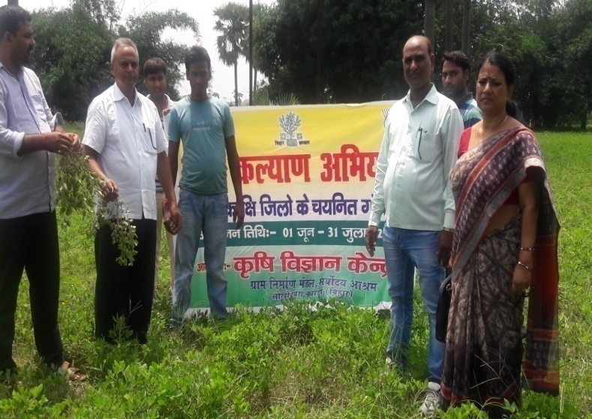 | 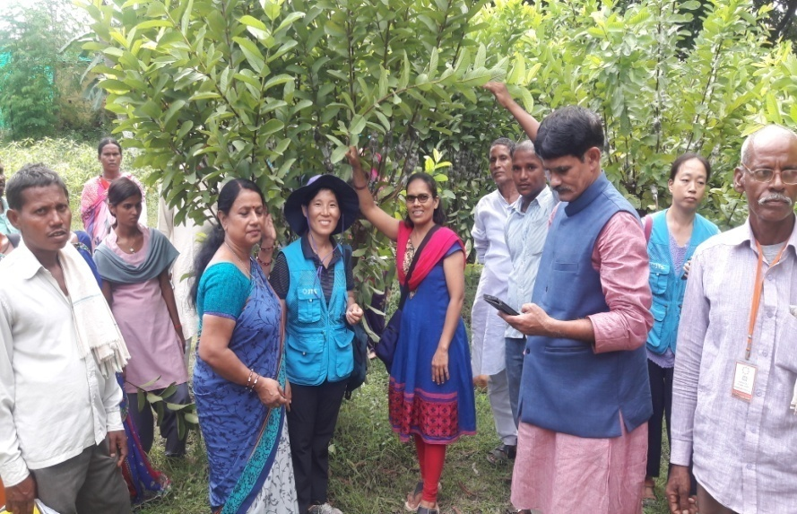
Field visit during Krishi Kalyan Abhiyan | KVK scientist and General seceratry explaining activitesi of KVK
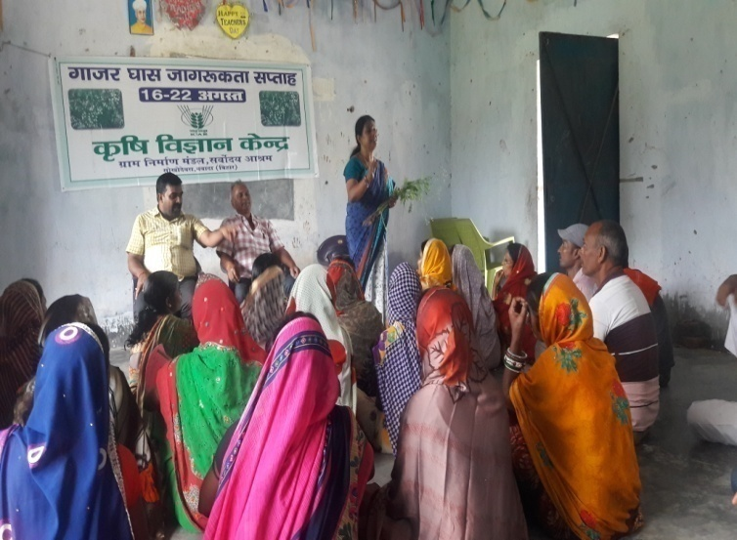 | 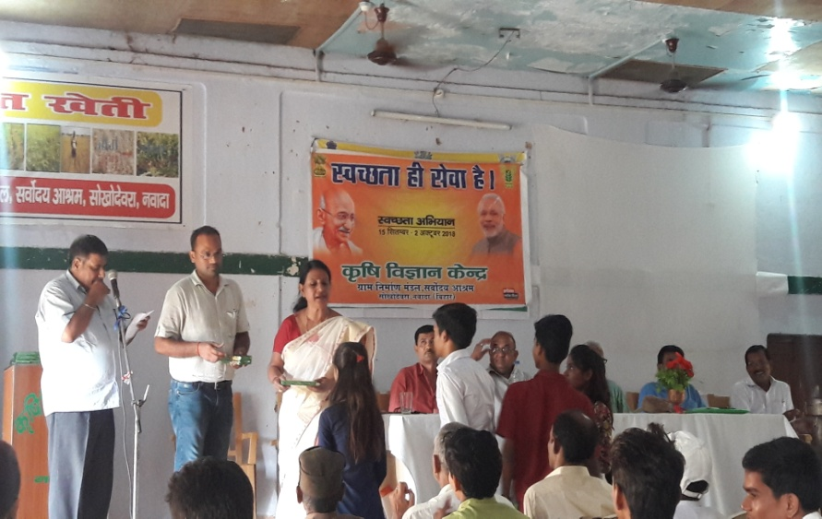
Awareness programme on parthenium day | Distribution of prize during swatchta hi seva hai
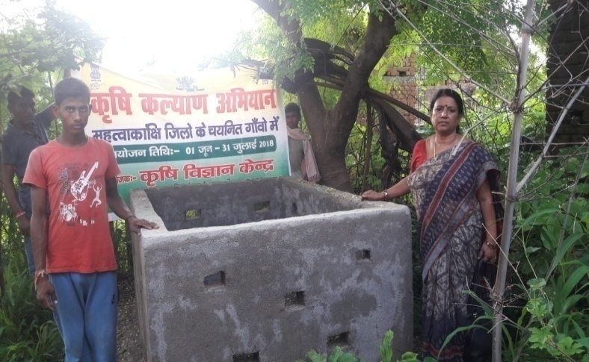 | 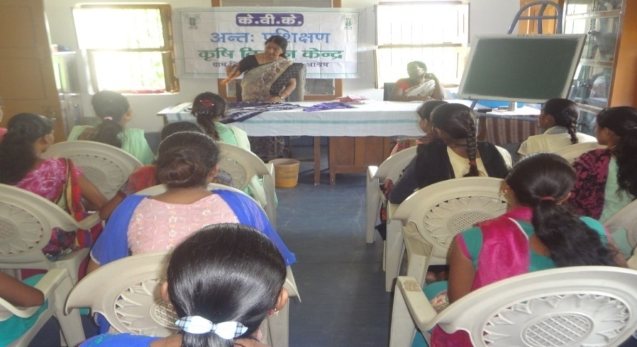
NADEP mamking under Krishi Kalyan Abhiyan | On campus training of rural youth
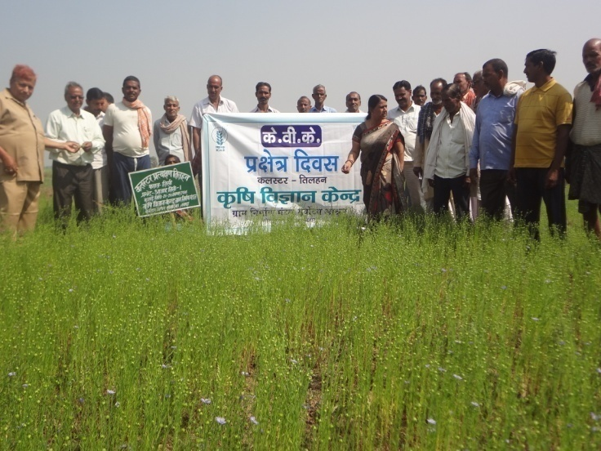
Field day cum training programme under CFLD

